Circle the Antonym for each underlined word
- The big dog ran down the street
  - Large
  - Small
  - Happy

- Sally felt sad when she dropped her ice-cream cone.
  - Joyful
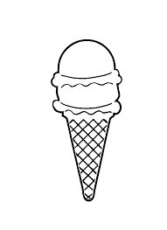
  - Unhappy
  - Bored

- Joe ran fast in the race last Saturday.
  - Quickly
  - Slow
  - Backwards

- I think peas are disgusting!
  - Gross
  - Green
  - Delicious

- Amy’s keeps her room very clean.
  - Dark
  - Messy
  - Tidy

- The movie we saw last week was quite frightening!
  - Funny
  - Bright
  - Scary

