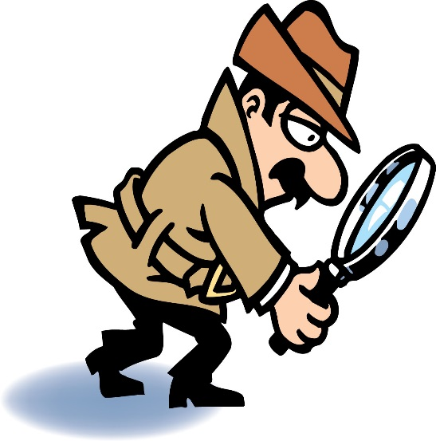

* Hard

◻  SOFT How Many did you find?

◻  Shiny

◻  Dirty

◻ bright

◻ Empty

◻ round

◻ Square

◻ Green

◻ Spin

◻ Push

◻ Hear

◻ Squeeze

◻ Color

◻ Fold

◻ Stir

◻ Shake

Attributes 1- Scavenger Hunt

Dear Parents: Please help your child find items that fit the description below. See how many they can find and then have them tell 3 things about the item that they found!