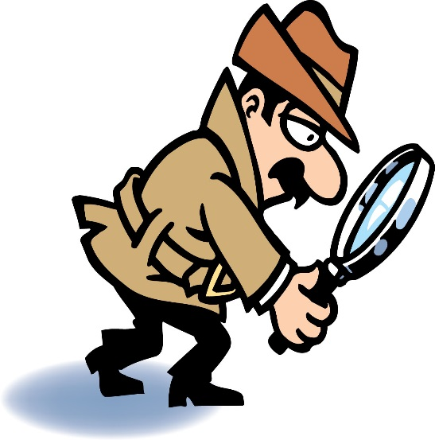

* Crunchy

◻  Smooth How Many did you find?

◻  Sparkly

◻  Long

◻ Wooden

◻ Slimy

◻ Hot

◻ Old

◻ Breakable

◻ Spin

◻ Push

◻ Hear

◻ Squeeze

◻ Color

◻ Fold

◻ Stir

◻ Shake

Attributes 2- Scavenger Hunt

Dear Parents: Please help your child find items that fit the description below. See how many they can find and then have them tell 3 things about the item that they found!