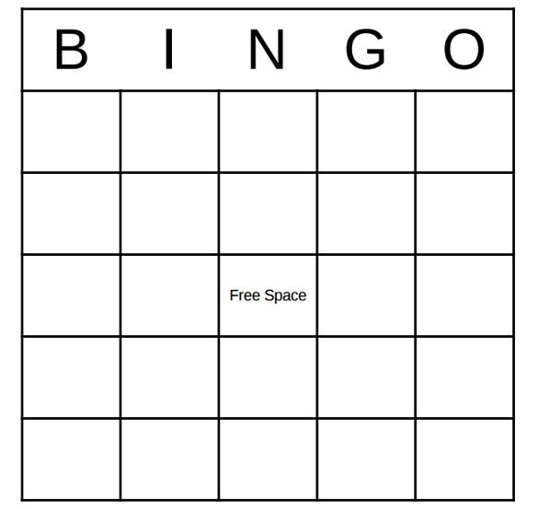

- Write 1 word in each of the Bingo squares with the specific sound that is being targeted. Repeat each word x3.
- If targeting specific sounds at the phrase or sentence level, create a phrase or sentence including the targeted sound.

