Conversation
Chutes & Ladders

Make a comment = Move forward 3 spaces
Ask a question = Move forward 4 spaces
Break a conversation rule = Move back 2 spaces

Conversation Rules:

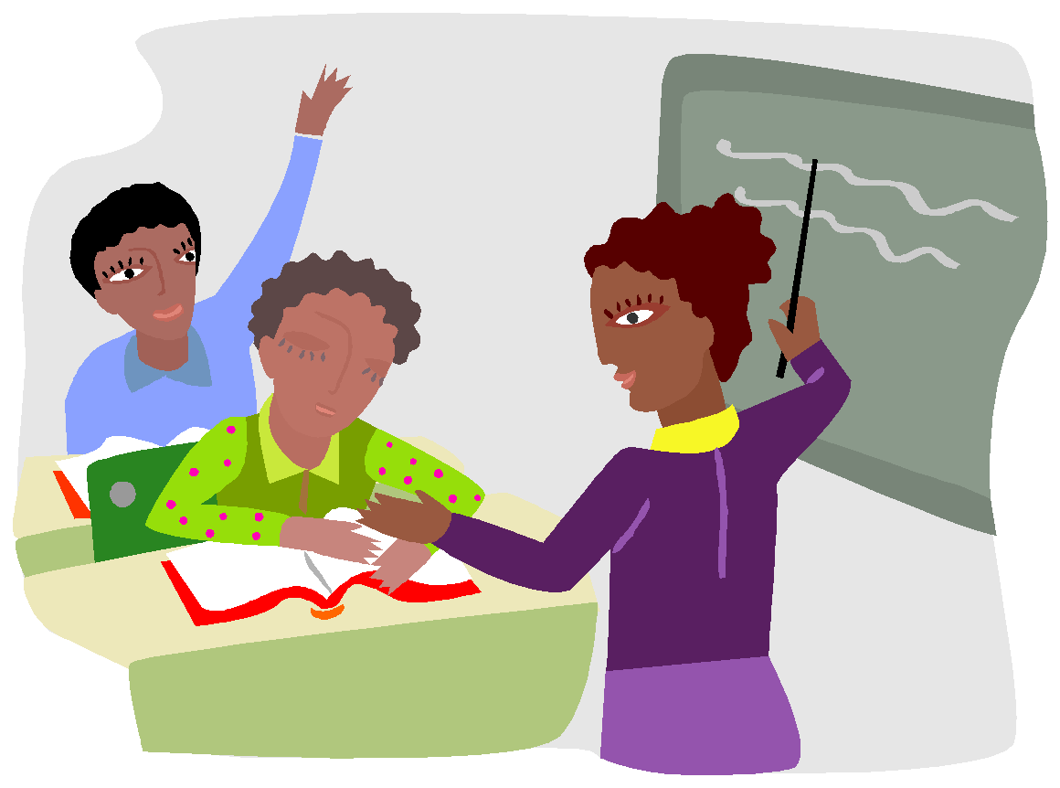
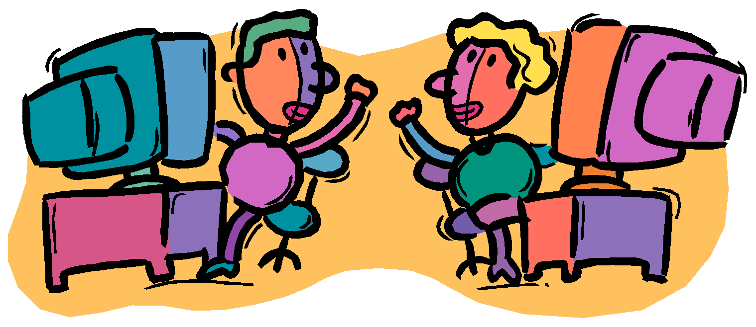
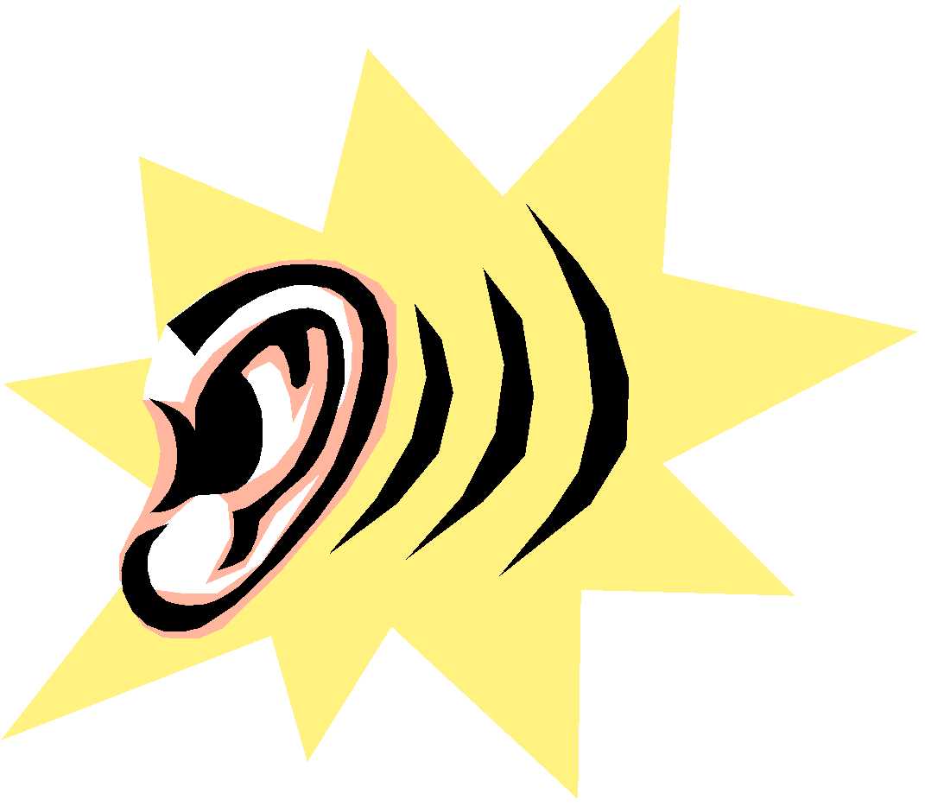
Take turns Listen Look at the speaker Stay on-topic

