Following Directions
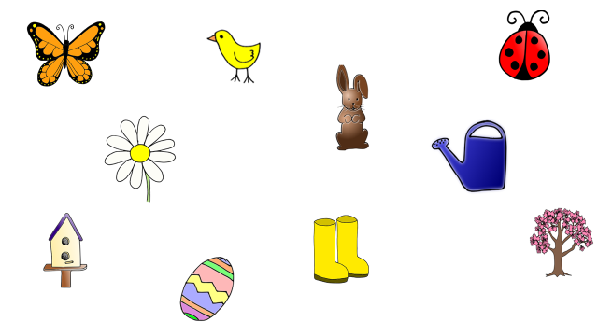

Pick the direction that matches your student’s level. Add your own directions, too. Before starting, talk about each picture.
1 Step Directions: 2 Step Directions: (Basic) 2 Step Directions: (Complex)
Point to the butterfly. Point the flower then the tree. Point to the egg before you point to the tree.
Point to the ladybug. First point to the chick then the egg. Point to the watering can before you point to the chick
Point to the chocolate bunny. Point to the watering can then the butterfly. Before you point to the boots, point to the birdhouse.
Point to something blue. Point to something you wear and something that flies. Before you point to the chocolate bunny, point to the chick

3 Step Directions:
First point to the rain boots, then the egg, and last the chick.
Point to the watering can, ladybug, and tree.
First point to the ladybug, then the bunny, and last the flower.
Point to something blue, something you eat, and something that flies.

Pictures from Lesson Pix

